November 2017

Dear Flex Owner,
Enclosed is your 2019 Flex Reservation Form, along with the calendar, which is printed on the reverse side of this letter for your reference.
To confirm your reservation, please complete the form and return it to The Charter Club of Marco Beach by
FAX: (239) 394 4327, Mail: 700 South Collier Blvd., Marco Island, FL, 34145 or E-mail: afoster2@hgvc.com. Keep the proof of fax, mail or e-mail for future reference. Your $20 Flex Reservation Fee for 2019 has been included on your 2018 maintenance fee billing. All Flex reservations received by January 1, 2018, are grouped together, with reservations selected at random from this group to ensure fairness to all Owners. All Flex reservations received after January 1, 2018, are processed on a first-come, first serve basis.
- Hilton Grand Vacations Members: If you want to request Points for your week, mark appropriate box and include your member number, do not select any week. If you want to Request Accommodation, fill out all 3 choices.
- RCI Members: Your Maintenance Fee has to be paid prior to Spacebanking your unit! If you want to “Spacebank” your week, mark appropriate box and include your RCI number, don’t select any week. We will deposit your week with RCI for you. A Spacebank Acknowledgement Card will be sent by RCI between 7 and 14 days after the reservation has been made, as verification of your deposit. If you do not receive the acknowledgement card, please contact RCI directly at
1-800-221-6400.
- You will receive your confirmation by the end of January 2018 or once your reservation has been made.
If you need further assistance, please contact Reservations at (239) 394-4192. We look forward to hearing from you.
Sincerely,
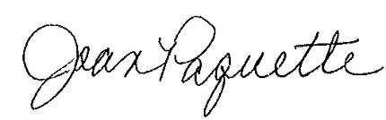
Joan Paquette
Resort Director
Enclosure

